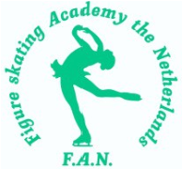 Figure Skating Academy the Netherlands
ANNOUNCEMENT
proudly invites to attend the 10th

on
December 2nd & 3rd 2023
at
Ice sports center Eindhoven, the Netherlands
A figure skating singles competition ranging in categories from Cubs, Chicks, Mini , Basic Novice B, Intermediate Novice, Advanced Novice B, Junior B, Adult Master, Gold, Silver, Brons
Official invitation and announcement
Closing date November 15th 2023
Figure skating Academy the Netherlands is pleased to announce the 10 'City of Light Trophy', an international figure skating competition for single skating in following categories (each category is available for Boys & Girls):
Cubs, Chicks
Mini, Midi, Maxi
Basic Novice B
Intermediate Novice
Advanced Novice B
Junior B
Adult Master, Gold, Silver, Brons

PLACE AND DATE
The competition will be held on December 2nd and 3rd 2023 in Eindhoven, the Netherlands. All competition events will take place at the indoor figure skating ice rink (60x30 meters) at the ice sports center, Eindhoven.
CLOSING DATE OF ENTRY
November 15th 2023, 23:59h
ACCREDITATON
Will be possible on Saturday December 2nd from approx. 07.00h on at the ice rink.

DRAW
Will be applied to all categories by a computer generated system producing the starting order.

TIME TABLE
Will be made available on the website /Facebook page as soon as possible after the closing date. Changes may occur due to technical requirements of the judging system and/or exceeding number of entries.

Saturday December 2nd
Scheduled: 8:00h – 19:00h

Sunday December 3rd
Scheduled: 8:00h – 18:00h

ORGANISATION
Figure skating Academy the Netherlands with support of the Royal Dutch Skating Federation.

F.A.N. Competition secretary
Mrs.H. Naaktgeboren Tel:+31612467863 @Mail: wedstrijdsecretariaat@figureskatingacademy.nl

JUDGES AND/OR TECHNICAL SPECIALISTS
For international entries; please inform the organizing committee in case you're considering adding a judge and/or technical specialist to the competition. These request will then be made known to the Dutch Skating Federation. All categories will be judged with the ISU judging system.

GENERAL REGULATIONS
The competition will be conducted in accordance with ISU Regulations 2023 and all recent communications for figure skating (single skating). All categories abide to regulations according to the ISU judging system and will be judged as such. All competitors must be eligible persons in accordance with ISU Rule 102 and must meet the participation, citizenship and residency requirements in ISU rule 109 and communication no 1117. All skaters who do not have nationality of the member by which they have been entered or who, although having such nationality, have in the past represented another member, must produce an ISU clearance certificate.
COMPETITION

MUSIC
To minimize direct contact during the competition the music playback will be exclusively digital (via computer).
Skaters/clubs from all countries should send their music by E-mail
coachesteam@figureskatingacademy.nl
The send music files must show competitor’s name, nationality, category, program(free skating). Mandatory music format is . mp3 file format.
We highly recommend to send the music files very soon after confirmation of participation.
This will give us time to check compatibility of the music and the to contact participating clubs if problems should arise.

Planned Program Content Sheet

Skaters from all countries must send the Planned Program Content Sheet along with the entry forms to the Organizing Committee till November 15,2023, by email to:
secretariaat@figureskatingacademy.nl

PRIZES
Each of the winning competitors will be presented with a trophy. Also, during the victory ceremony all competitors are invited on to the ice in order to receive a memento. The protocol will be uploaded on to the homepage immediately after the closing of the competition. Clubmembers or coaches are allowed to collect trophies that belong to participants that were forced to leave early before completion of the victory ceremony.

ACCOMODATION AND TRANSPORTATION
Accomodation as well as transportation from and to the ice rink has to be organized by the participant. However, please feel free to contact our organizing committee with any questions. We encourage you to visit the website for the city of Eindhoven, which amongst other things includes hotel recommendations: www.thisiseindhoven.com

LIABILITY
The organizing committee holds no liability for injuries or damage sustained by competitors on any competition day.
ENTRY FORM
For international entries, please use the official entry form.

LIMITATIONS
The organization is adhering to decisions made by the Dutch Skating Union (dep. of figure skating) for competitions in season 2023-2024. Technical scores earned at this year's competition are applicable for any of the Dutch national finales (A/B-circuit).
The organization committee reserves the right to limit entries for all categories. Entries will be accepted on a first come, first served basis; up to the maximum in relation to the available competition hours. The organizing club will follow the order mentioned by the clubs on their entry form. Following rules of entry apply to all participating clubs:
- Every club has the right to enter a maximum of 3 skaters in each category (Boys & Girls). In addition, every club may register 3 skaters as back-up (for Dutch entries via Figure Skating Online, please enter these skaters under header 'substitute'). These skaters may only replace the original entry for the competition before the results of the first draw or can be added by the organizing club only in case the competition schedule allows more entries overall.
- The organizing club has the right to enter an unlimited number of participants in all categories.

ENTRANCE FEE
€ 60,00 per participant . The payment must be made in full by November 16th. No refunds can be given.

Bank Rabobank
Account Holder F. A. N.
IBAN/Rekeningnummer NL14 RABO 0163 8463 83
BIC RABONL2U
No charges for the beneficiary. No cheques will be accepted. Payments made after the proposed date will result in an additional administration fee of 10,- € per skater.

ICE RINK
IJssportcentrum Eindhoven
Antoon Coolenlaan 3
5644 RX Eindhoven
The Netherlands
GPS coordinates: 51°24'54"N 5°28'17"E Website: www.ijssportcentrum.nl
Snacks, lunch and dinner are available at the ice rink cafeteria!
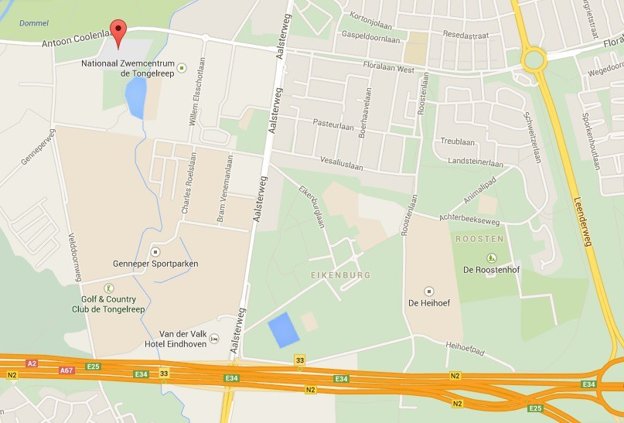

CATEGORY INFORMATION
Important!
For all categories; the reference date for the skaters age is 01.07.2023 (the 1 ^{st} of July 2023).<

Chicks Girls & Boys
Age requirements-Chicks is a skater who was born:01.07.2015 and younger (not 8). Free skating 2 min +/- 10 sec

Cubs Girls & Boys
Age requirements – Cubs is a skater who was born: 01.07.2013 -30.06.2015 (minimum 8 and not 10) Free skating : 2 min +/- 10 sec

A well balanced Free Skating program for Chicks & Cubs
Single Boys & Girls must contain:
- Maximum of 4 jump elements for Girls and Boys. There may be up to two (2) jump combinations or sequences. Jump combinations can contain only two (2) jumps. Any single or double jump may be executed only twice in total. Triple jumps are not permitted.
- There must be a maximum of two (2) spins of a different nature (abbreviation).Flying Entry is allowed.
- There must be a maximum one (1) step sequence with a fixed Base value and evaluated in GOE only. The sequence must cover at least half of the ice surface to be counted.
The Program Components are only judged in
- Composition
- Presentation
- Skating Skills
The Factor of the Program Components is 1.67
Deductions (e.g. falls, time violation): -0,5

Levels explanations:
In all elements which are subject to Levels, only features up to Level 2 to be counted.
Any additional features wil not count for Level requirements and will be ignored by the Technical Panel.

Mini
Ages boys & girls: up to the age of 10 yrs
Dutch entries: MIF Interbrons (Pre-preliminary MIF)
Free Skate only
Music time: 2.30 minutes +/- 10 seconds

Midi
Ages boys & girls: between 11-13 yrs old
Dutch entries: MIF Interbrons
Free Skate only
Music time: 2.30 minutes +/- 10 seconds

Maxi 1 & 2
Ages boys & girls: 14-17 yrs maxi 1
Ages boys & girls 18+ yrs maxi 2
Dutch entries: MIF Interbrons
Free Skate only
Music time: 2.30 minutes +/- 10 seconds

Basic Novice B
Ages boys & girls: 13+ yrs
Dutch entries: MIF Zilver (Juvenile MIF)
Free Skate only
Music time: 3.00 minutes +/- 10 seconds
Free skate content: Mini, Midi, Maxi ,Basic novice B
Free Skate content:
(all single/double jumps, including single Axel, are allowed)
(Axel is not required for categories Mini, Midi, Maxi)
- – 5.: A maximum of 5 jumps, one of which must be an Axel-type jump (allowed are 2 jumpcombinations
or 1 jumps combination and 1 jumps sequences; in the sequence is only Axel (second jump)
allowed a jumpcombination can not consist of more than two jumps)
6. Combination spin with (min. of 8 revolutions) or without change of foot (min. of 6 revolutions), flying
entry allowed
7. Spin in one basic position(min of 6 revolutions); change of foot is allowed (min. of 8 revolutions)
flying entry allowed
8. Max.1 step sequence; a series of steps covering the entire length of the ice rink (mini, midi, maxi)
8. Choreographic Sequence consisting of at least two different movements (Basic novice B)

Intermediate Novice
Ages boys &girls
Has not reached the age of fifteen (15yrs)
ISU communic.2562 Techn. Rules Single and pair Skating 2022
Free Skating : 3 min +/- 10 sec

Advanced Novice B
Ages boys & girls: 15+ yrs
Dutch entries: MIF Intergoud ((Intermediate MIF)
Free Skate only Music time:
Boys & Girls: 3:00 minutes +/- 10 seconds
Free Skate content (Boys & Girls):
1.-6. A maximum of 6 jumps, one (1) of which must be an Axel-type jump (allowed are 2 jump combinations
or sequences; a jump combination can consist 3 jumps, triple jumps are allowed; only 2 jumps of 2 ½
or more rotations may be repeated) Any single jump cannot be executed more than twice in total.
7. Combination spin with change of foot (min. 8 revolutions), flying entry is not allowed.
8. Flying spin (min. 6 revolutions) or spin with flying entry in one position with one change of foot (min. 8
revolutions)
9. Choreographic sequence

Junior B
Ages boys & girls: 19+ yrs
Dutch entries: MIF Goud (Novice MIF)
Free Skate only Music time:
Boys & Girls: 3:30 minutes +/- 10 seconds
Free Skate content:
1.-7.: A maximum of 7 jumps (Boys & Girls), one (1) of which must be an Axel-type jump (allowed are 3
Jump combinations or sequences; or 2 jump combination and 1 jumps sequence ,one jump
combination may consist of three jumps)
8.: Combination spin ( min 10 revolutions)
9.: Flying spin with flying entry (min 6 revolutions)
10.: Spin in one position (min 5rev,) ,with change of foot (min 8 revolutions)
11.: Choreo Sequence

Adult
Ages 28+
Adult Guidelines ISU

Adult Master
Free Skate only Music time: 3:00 min +/- 10 seconds
3 components :max. Level 4

1-6. A maximum of 6 jumps, one (1)of which must be an Axel-type jump, single/double/triple jumps are
allowed.
Max 2 jump combinations and 1jump sequence is allowed (1 jump combinations with 3 jumps,
2 jump combinations with 2 jump is allowed .Any jumps cannot be executed than twice(2x) in total.
7. Flying spin with flying entry 5) with change of foot (min 8 revolutions)
8. Spin in one position (5 rev.)with change of foot (8 revolutions)
9. Combination spin (min 8 revolutions)
10. Step Sequence fully utilizing the ice surface

Adult Goud (Gold)
Free Skate only Music time: 2:50 min +/- 10 sec
3 components : max. Level 3

1.-5. A maximum of 5 jumps single /double is allowed. 2F,2Lz,2A is not allowed.
Max. 3 jump combinations or 2 jump combination and 1 jump sequence is allowed.1 Jump combination
or jump sequence may consist of three jumps).
Any jumps cannot be executed than twice (2x) in total.
6. Flying spin with flying entry (4)with change of foot (8 revolutions)
7. Spin in one position (4) with change of foot (8 revolutions)
8. Combination spin (min 8 revolutions)
9. Step sequence fully utilizing the ice surface

Adult Zilver (Silver)
Free Skate only Music time: 2:00 min +/- 10 sec
3 components; max. Level 2

1.-5. A maximum 5 single jumps
Max. 2 jump combinations or 1 jump combination and 1 jump sequence is allowed. 1 jump combination
or jump sequence may consist of three jumps.
Any jumps cannot be executed than twice (2x) in total.
6.-7. Two (2) spins of a different nature (min 4 rev.) with change of foot (min. 6 revolutions)
8. Choreo Sequence min. ½ utilizing the ice surface

Adult Brons (Bronse)
Free Skate only Music time 1:40 min +/- 10 sec
3 components ; max. Level 2

1.-4. A maximum 4 single jumps, 1Axel is not allowed
Max. 2 jumps combinations. Jump combination consist of two(2) jumps.
Any jumps cannot be executed than twice(2x) in total.
6.-7.Two (2) spins in one position of different nature (min 3 rev.) with change of foot (min.6 revolutions)
Flying entry is not allowed
8. Choreo Sequence min.1/2 utilizing the ice surface

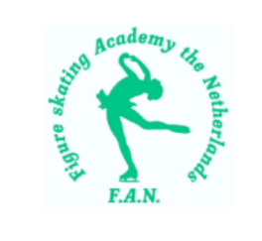
REGISTRATION FORM City of Light Trophy 02.-03.12 2023 in Eindhoven
Club name:
Address of secretary
Postcode and place
Person of contact
Telephone number
E-maladdress
 | Name | Date of birth | M/V | Category | License Number
1
2
3
4
5
6
7
8
9
10
11
12
13
14
15
Total registration fee: € ........................(registration fee per participant € 60,00)
The closing date for the registration is 15.11.2023 at 23.59 pm. The date of sending counts as registration date. Payment of registration fee before 19.11.2023.
Bank number: NL 14 RABO 0163 8463 83 t.n.v. Figure Skating Academy the Netherlands Eindhoven. Please send the registration form to: wedstrijdsecretariaat@figureskatingacademy.nl .
Person of contact: Han ter Mors (secretaris) +31612 41 1907 ------------------------ - Hana Naaktgeboren +31612 46 7863

