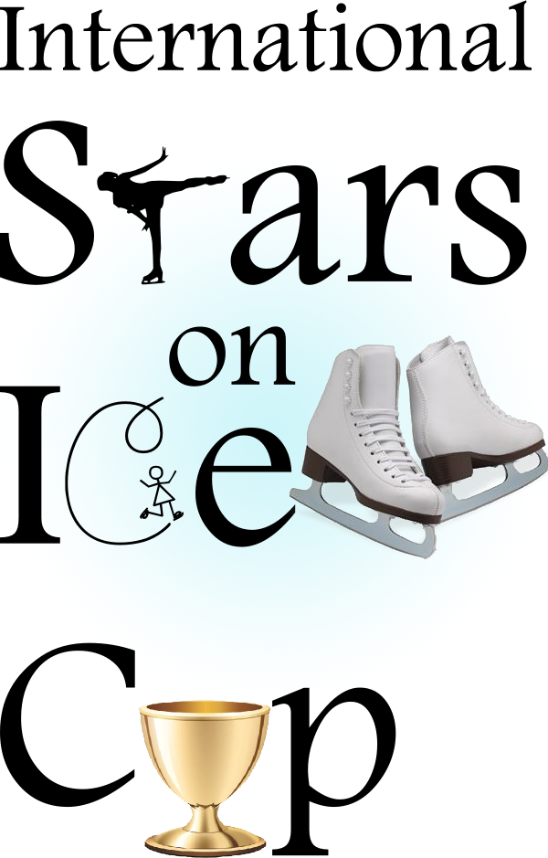
Dear skaters,

We are pleased to invite you for the international competition Stars on Ice Cup, which will take place on the 28th of January and 29th of January 2017 in the ice rink of Zoetermeer in the Netherlands.

The competition is for beginners till senior level as well for girls and boys in.

Next to the regular classification, the skaters competing in this international competition will also be able to win the Stars on Ice Cup. The rules are explained in the following invitation.

We wish you a lot of success in the competition.

For further information, please contact us or check our website www.starsonice.org

Sincerely,

Stars on Ice

Jose Lew

Secretary

+31793315422
Information:
The stars on Ice Cup is an international competition for single skating. The competitors will skate their free program.
Organisation
The club Stars on Ice will be organizing the competition.

Secretary:
Jose Lew
Vaartdreef 128
2724 GJ Zoetermeer
The Netherlands
Tel: +31 (0) 79 3315422
e-mail: starsonice@hotmail.nl

- Ice rink:
Silverdome (60 m x 30 m), (196ft x 65ft)
Van der Hagenstraat 20
2722 NT Zoetermeer
The Netherlands
Tel: +31 (0) 79 330 5000
Website: www.silverdome.nl

In the Ice rink there is the opportunity to buy food and drinks in the restaurant.

- The competition
3.1 Registration
Every figure skating club can register for the international competition Stars on Ice Cup. This invitation has been sent to several figure skating bonds in several countries. The competing skaters will skate their free program and the competition will take place in two days.
The total numbers of participants can be limited according to the availability of the ice.
The possibility to register the skaters will end on the 10th of December 2016.
Please fill in the official entry form to register.
3.2 Categories single skating
- Twinkle Stars (NL: Starter)
- Rising Stars (NL: Pupillen)
- Super Stars (NL: Aspirant)
- Future Stars (NL: Mini, midi and maxi)
- Pre basic novice
- Basic novice
- Advanced novice
- Junior
- Senior
When the number of skaters in a category is exceeded, the rule that will be applied will be: full=full.
3.3 Rules for the Cup
To be competing as a club in the Stars on Ice Cup you have to register a minimum of 5 skaters. At least 3 competitors have to compete in the three different score cart categories.
These Categories are:
- Twinkle Stars
- Rising Stars
- Super Stars
For example :
Competitor | Example 1 | Status | Example 2
1 | Twinkle Stars | Required | Twinkle Stars
2 | Rising Stars | Required | Rising Stars
3 | Super Stars | Required | Super Stars
4 | Twinkle Stars | Optional | Pre basic A
5 | Super Stars | Optional | Junior B
6 | Reserve |  | Reserve

To win the cup the end positioning mark will be the starting point. Every club competing will have to register ahead which 5 participants they want to select to get the points for the cup and 1 reserve participant. The cup will be won as a club.

3.4 Lottery, starting order and time schedule
The competition will be held within two day. The lottery of the starting order will take place on the 15th of January 2017 at 12.00 in the Silverdome in Zoetermeer. The starting order and time schedule will be announced on the website after the lottery, we will do this as fast as possible.
3.5 Music
The music for the program must send to http://kunstschaatsacademiestarsonice.nl/starsonicecupmuziek before the closing date.
3.6 Judging
The competitors Twinkle Stars, Rising Stars, Super Stars will be judged with an scorecart. See regulations.
The competitors Future Stars, Pre basic novice B, Basic Novice B, Advanced novice B, Junior B will be judged with paper system (ISU off-line system).
The competitors Pre basic novice, Basic Novice, Advanced novices, Junior and Senior will be judged with the ISU judging system, this judgement will be done without a replay.
Expenses:
4.1 Registration fee
The registration fee for each skater is as following:
Twinkle Stars (NL: Starters) € 45,- for each skater
Rising Stars (NL:Pupillen) € 45,- for each skater
Super Stars (NL:Aspirant) € 45,- for each skater
Future Stars (NL:Mini,Midi and Maxi) € 50,- for each skater
Pre basic novice (B) € 50,- for each skater
Basic novice (B) € 50,- for each skater
Advanced novices (B) € 55,- for each skater
Junior (B) € 55,- for each skater
Senior € 55,- for each skater
Payment only by Bank at:
BIC: RABONL2U IBAN: NL90RABO0166125873
For the Netherlands RABOBANK: NL90RABO0166125873 on the name of Stars on Ice. Place: Zoetermeer

(No charges for the beneficiary).

No reimbursements will be made in case of withdraw of a skater.

The registration fee has to be paid before the closing date. Late payments will be handled with an administration fee of € 10,- .

The clubs competing in the Stars on Ice Cup are responsible for the payments by the bank and they are responsible for sending the right amount of money.

  - Liability

In accordance to ISU Regulations, all participants act at their own responsibility. The organizer will provide medical emergency aid during the competition.

- Coaches
The Coaches that are registered on the registration form will get a batch and will have excess to the Ice rink.

- Travel & lodging
The organizing committee does not pay travel or lodging expenses for the participating skaters.

- Groups and categories
For all categories: the reference date for the skaters age is 1st July 2016.
For example Rising Stars category: The skater has to have reached at least the age of 7, but has not yet reached the age of 11 by 1st of July 2016. If the skater turns 10 on or after the reference date, the skater will still be able to compete in the Rising Stars.

Groups Boys & Girls FP+/- 10 sec. Regulations

Twinkle Stars (NL: Starters) 0 to 6 yr 2.00 min See reg.

Rising Stars (NL: Pupillen) 7 to 10 yr 2.00 min See reg.

Super Stars (NL:Aspirant) 11 yr and older 2.00 min See reg.

Future Stars
Future Stars A (NL: Mini) 0 to 10 yr 2.00 min See reg.
Future Stars B (NL: Midi) 11 to 13 yr 2.00 min See reg.
Future Stars C (NL: Maxi) 14 yr and older 2.00 min See reg.

Pre basic novice
Pre basic novice 0 to 11 yr 2.30 min See reg.
Pre basic novice B 12 yr and older 2.30 min See reg.

Basic novice
Basic novice 10 up to 12 yr ISU
Basic novice B 13 yr and older 2.30 min ISU

Advanced novice
Advanced novice 10 up to 14 yr ISU
Advanced novice B 15 yr and older L 3.00/M 3.30 min See reg.

Junioren
Junioren 13 up to 18 yr ISU
Junioren B 19 yr and older L 3.30/ M 4.00 min See reg.

Senioren 14 yr and older ISU

Skaters will be categorised by age and level as much as possible. When the number of skaters in a group has exceeded the organisation can if necessary split up the group by age before the draw.

Regulations
Twinkle stars Warming-up 4 min

FS | Twinkle stars similar to Starters | Deductions |  |  | 4.0 | Bonus
 | No jumps
1. | Three turns forwards outside 3x in a row | 0.3 | 0.2 | 0.1 | 0 | 0.1 | 0.2 | 0.3
2. | Stork | 0.3 | 0.2 | 0.1 | 0 | 0.1 | 0.2 | 0.3
3. | Shoot the duck 1 or 2 feet | 0.3 | 0.2 | 0.1 | 0 | 0.1 | 0.2 | 0.3
4. | Drag | 0.3 | 0.2 | 0.1 | 0 | 0.1 | 0.2 | 0.3
5. | Spiral (basic, no variation allowed) | 0.3 | 0.2 | 0.1 | 0 | 0.1 | 0.2 | 0.3
6. | Upright spin (2 feet) | 0.3 | 0.2 | 0.1 | 0 | 0.1 | 0.2 | 0.3

Rising stars Warming-up 4 min

FS | Rising Stars similar to Pupillen | Deductions |  |  | 6.0 | Bonus
 | All single jumps allowed except for 1A
1. | Single jump at choice | 0.3 | 0.2 | 0.1 | 0 | 0.1 | 0.2 | 0.3
2. | Single jump at choice | 0.3 | 0.2 | 0.1 | 0 | 0.1 | 0.2 | 0.3
3. | Single jump at choice | 0.3 | 0.2 | 0.1 | 0 | 0.1 | 0.2 | 0.3
4. | Combination of 2 single jumps | 0.3 | 0.2 | 0.1 | 0 | 0.1 | 0.2 | 0.3
5. | Spin at choice change of foot optional | 0.3 | 0.2 | 0.1 | 0 | 0.1 | 0.2 | 0.3
6. | Spin at choice different then element 5 | 0.3 | 0.2 | 0.1 | 0 | 0.1 | 0.2 | 0.3
7. | Cross over forwards (8 vorm) | 0.3 | 0.2 | 0.1 | 0 | 0.1 | 0.2 | 0.3
8. | Tree turns forward outside (3x in a row) | 0.3 | 0.2 | 0.1 | 0 | 0.1 | 0.2 | 0.3
9. | Mohawk forwards inside (3x in a row) | 0.3 | 0.2 | 0.1 | 0 | 0.1 | 0.2 | 0.3
10. | Spiral (min. 3 sec, no variation allowed) | 0.3 | 0.2 | 0.1 | 0 | 0.1 | 0.2 | 0.3

Super stars Warming-up 4 min

FS | Super Stars similar to Aspiranten | Deductions |  |  | 6.0 | Bonus
 | All single jumps allowed except for 1A
1. | Single jump at choice | 0.3 | 0.2 | 0.1 | 0 | 0.1 | 0.2 | 0.3
2. | Single jump at choice | 0.3 | 0.2 | 0.1 | 0 | 0.1 | 0.2 | 0.3
3. | Single jump at choice | 0.3 | 0.2 | 0.1 | 0 | 0.1 | 0.2 | 0.3
4. | Combination of 2 single jumps | 0.3 | 0.2 | 0.1 | 0 | 0.1 | 0.2 | 0.3
5. | Spin at choice change of foot optional | 0.3 | 0.2 | 0.1 | 0 | 0.1 | 0.2 | 0.3
6. | Spin at choice different then element 5 | 0.3 | 0.2 | 0.1 | 0 | 0.1 | 0.2 | 0.3
7. | Cross over forwards (8 vorm) | 0.3 | 0.2 | 0.1 | 0 | 0.1 | 0.2 | 0.3
8. | Tree turns forward outside (3x in a row) | 0.3 | 0.2 | 0.1 | 0 | 0.1 | 0.2 | 0.3
9. | Mohawk forwards inside (3x in a row) | 0.3 | 0.2 | 0.1 | 0 | 0.1 | 0.2 | 0.3
10. | Spiral (min. 3 sec, no variation allowed) | 0.3 | 0.2 | 0.1 | 0 | 0.1 | 0.2 | 0.3

Future stars Warming-up 4 min

FS | Future Stars similar to Mini, Midi and Maxi
1.  2. 3.  4. | Max. 4 jump elements.  In the 4 jump elements there may be maximum of 2 jump combinations and/or sequences performed. A jump combination may only consist out of 2 jumps. And a jump sequences may consist of more jumps but only the 2 most difficult jumps will be counted.
5. | Combination spin with or without change of foot (min.6)
6. | Spin in one position with or without change of foot (min 6)
7. | Step sequence
 | In both spins flying entry is allowed.

Level explanations:
For Future Stars A, in all elements which are subject to levels, only features up to level 2 will be counted. Any additional features will not count for level and will be ignored by the technical panel.

Pre basic novice (B) Warming-up 5 min

FS | Girls and Boys
1.  2. 3.  4. | Max. 4 jump elements one of which must be an axel jump.  In the 4 jump elements there may be maximum of 2 jump combinations and/or sequences performed. A jump combination may only consist out of 2 jumps. And a jump sequences may consist of more jumps but only the 2 most difficult jumps will be counted.
5. | Combination spin with or without change of foot (min.6)
6. | Spin in one position with or without change of foot (min 6)
7. | Step sequence
 | In both spins flying entry is allowed.

Level explanations:
For Pre basic novice and Pre basic novice B, in all elements which are subject to levels, only features up to level 2 will be counted. Any additional features will not count for level and will be ignored by the technical panel.

Basic novice Warming-up 6 min

Requirements of the competition conform Basic novice communications No. 2024.

Basic novice B Warming-up 5 min

FS | Girls and Boys
1.  2. 3.  4. | Max. 4 jump elements one of which must be an axel jump.  In the 4 jump elements there may be maximum of 2 jump combinations and/or sequences performed. A jump combination may only consist out of 2 jumps. And a jump sequences may consist of more jumps but only the 2 most difficult jumps will be counted.
5. | Combination spin with or without change of foot (min.6)
6. | Spin in one position with or without change of foot (min 6)
7. | Step sequence
 | In both spins flying entry is allowed.

Advanced novices Warming-up 6 min

Requirements of the competition conform Novice Advanced communications No. 2024.

Advance novice B Warming-up 5 min

FS | Girls and Boys
1/6 | Max. 6 jump elements (boys 7 jump elements) one of which must be an axel jump.  In the 6 jump elements (boys 7 elements) there may be maximum of 2 jump combinations and/or sequences performed. A jump combination may only consist out of 2 jumps. And a jump sequences may consist of more jumps but only the 2 most difficult jumps will be counted. When you perform a jump combination the marks that you will get for the 2 jumps will be added. Only two (2) jumps with two and a half (2 1/2) or more revolutions can be repeated either in a jump combination or in a jump sequence.
7. | Combination spin with or without change of foot (min 8) flying entry not allowed
8. | Flying spin (min 6) or spin with flying entry in one position with one change of foot
9. | Step sequence

Level explanations:
For Advanced novice and Advanced novice B, in all elements which are subject to levels, only features up to level 3 will be counted. Any additional features will not count for level and will be ignored by the technical panel.

Junior Warming-up 6 min

Requirements of the competition conform Junior ISU.

Junior B Warming-up 5 min

FS | Ladies and men
1/7  1/8 | Max. 7 jump elements (boys 8 jump elements) one of which must be an axel jump.  In the 7 jump elements (boys 8 elements) there may be maximum of 3 jump combinations and/or sequences performed. One jump combination can consist of 3 jumps
9. | Combination spin
10. | Flying spin in one position or spin combination with a flying entrance
11. | Spin in one position
12. | Step sequence

Level explanations:
For junior B, in all elements which are subject to levels, only features up to level 4 will be counted. Any additional features will not count for level and will be ignored by the technical panel.

Senior Warming-up 6 min

Requirements of the competition conform Senior ISU.
Registration form Stars on Ice Cup:
Name club (full name): …………………………………………………………………

Name club (abbreviation): …………………………………………………………………

E-mail address secretary: …………………………………………………………………

Telephone number secretary: …………………………………………………………………

Names of the coaches: …………………………………………………………………
Name skater and sex | Date of birth | Group and category | Cup max. 5 skaters+R | Amount in €
1.
2.
3.
4.
5.
6.
7.
8.

Total registration fee € …………..………
At the square cup you can only register 5 skaters and 1 reserve skater, please do this by putting a cross by the participant whose score you want to count for the points to win the cup.
If you want to register more skaters please use another registration form.
Please take in consideration the price remark on the registration form.
You can send the registration form to starsonice@hotmail.nl
We will send you a confirmation of your registration within 2 days.

