

8.8.2014

Announcement of the International Figure Skating Competition
Promocup 2014

The figure skating Club SalPa taitoluistelu, Salo, Finland, has the pleasure to invite skaters
to participate in an international figure skating competition.

Time November 7-9 th, 2014
Venue Salon Jääliikuntahalli Oy (SSO Ice Rink) on Friday Nov 7th and Salo Ice Rink on Saturday-Sunday Nov 8^{th -}9th , Tahkonkatu 1, 24130 Salo, Finland. Ice rinks are located opposite of each other and both of them are cold.
Organizer Salon Palloilijat ry / Figure Skating division SalPa taitoluistelu
Website http://salpataitoluistelu.fi/

The competition will be held in the following single skating categories and classes:
Categories for Finnish Star Evaluation
- Junior C Girls, born 1995 or later
- Novice C Girls, born 2000 or later
- Debs B Girls, born 2002 or later
- Springs B Girls/Boys, born 2003 or later
- Cubs B Girls/Boys, born 2005 or later
Categories for ISU-evaluation
- Springs A Girls/Boys, born 2003 or later (FS)
- Debs A Girls/Boys, born 1.7.2001 or later (FS)
- Novice B Girls, born 1.7.1999 or later (FS)
- Junior B Girls, born 1.7.1995 – 30.6.2001 (SP/FS)
- Junior A Girls, born 1.7.1995 or later (SP)
- Senior B Ladies, born 30.6.1998 or before (SP/FS)
- Senior A Ladies (SP)

Technical requirements can be found in Annex 1, which will be published in the website http://salpataitoluistelu.fi in September.
Entries
All clubs, members of national figure skating federations associated with the ISU, are invited to take part in the competition. Each club has the right to enter competitors in any category and class. The clubs are asked to list the skaters in the order, in which they wish to be accepted to the competition. The Organizer reserves the right to limit participants, in case the number of entries is too high. The Organizer club has the right to enter more participants than other clubs. To participate, please fill in the entry form (Annex 2) and email it to kilpailut.salpataitoluistelu@gmail.com by October 19, 2014. Entries received after the deadline will not be accepted. Confirmation will be sent by October 24, 2014.

Entry fees / skaters
Categories with Finnish Star Evaluation 45 €
Categories with ISU evaluation, only SP 55 €
Categories with ISU evaluation, only FS 60 €
Categories with ISU evaluation, SP and FS 80 €

The entry fee should be paid by October 31, 2014.
The payment details SWIFT/BIC : HELSFIHH
Bank account IBAN : FI4843272120000611
In favour of : Salon Palloilijat ry / Taitoluistelu
We kindly ask the clubs to make one payment transaction for all participants. Please include the name of your club in the payment details. In case a skater has been entered in the competition, but cannot participate, she/he can be replaced by another skater in the same category and class. Participating clubs are asked to immediately inform of any changes in their entries by e-mailing kilpailut.salpataitoluistelu@gmail.com

Cancellations

After October 30, 2014 at 4 pm, only cancellations verified by a medical certificate will be refunded. In all cases of cancellations after October 30, a fee of 15 € to cover organizer’s office costs has to be paid.

Draw
On October 30th, at Salo Ice Rink, at 4 pm. The draw will be made by a random number generator in Finnish Star Evaluation catergories and by ISU Calc –program in ISU categories. The result of the draw will be published on the competition website on Oct 31st, 2014.

Practice Ice

Practice ice is for competitors who have indicated in the Entry form their desire to participate the practice ice. No program music will be played on practice ice time. Practice schedules and groups will be posted on competition’s website. Practice ice fee is 5 €/20 minutes. The practice ice fee is asked to be payed in the same payment transaction as entry fee.

Schedule
Finnish Star categories will be organized on Friday afternoon and evening at SSO Ice Rink. ISU categories will be organized on Saturday and Sunday at Salo Ice Rink. The final schedule with starting orders will be published on the competition website on Oct 31st, 2014.

Preliminary Schedule

Friday 7th of November, 2014
Finnish Star Evaluation

Category/Class | Time | Number or groups | Number of participants
Cubs born 2005 or later | 12:00 - 13:40 | 3 | 25
Springs B | 14:00 - 15:41 | 3 | 24
Debs B | 16:00 - 17:42 | 3 | 21
Novice C | 18:00 - 19:08 | 2 | 14
Junior C | 19:08 - 19:44 | 1 | 7
Practice | 19:45 – 20:25 | 2

Saturday 8th of November, 2014
ISU evaluation

Category/Class | Time | Number or groups | Number of participants
Debs A Girls, FS | 08:00 - 10:22 | 3 | 24
Debs A Boys, FS | 10:22 - 11:04 | 1 | 6
Senior B Ladies, SP | 11:30 - 12:32 | 2 | 10
Junior B Girls, SP | 12:32 - 13:09 | 4 | 24
Junior A Girls, SP | 15:30 - 16:19 | 1 | 7
Senior A Ladies, SP | 16:19 - 16:50 | 1 | 4
Springs A Girls, FS | 17:15 - 18:26 | 2 | 12
Practice | 18:30 – 19:10 | 2

Sunday 9th of November
ISU evaluation
Category/Class | Time | Number or groups | Number of participants
Novice B, FS | 08:00 - 10:22 | 3 | 22
Junior B, FS | 11:00 - 14:35 | 4 | 24
Senior B Ladies, FS | 14:35 – 15:57 | 2 | 10

Awarding
Three first standings of each category/class will be awarded with a cup. All participants will receive a diploma. Awarding ceremonies will be held on the next possible ice resurfacing break as soon as the results are confirmed.

Music
CD (no re-writable discs). All competitors must have a spare competition music-CD immediately available during their performance.

Planned Program Components

Entries in ISU-categories, please attach the planned program component sheet (Annex 3 or 4) to entries. All planned program component sheets must be delivered by email to address kilpailut.salpataitoluistelu@gmail.com at latest Nov 3 th, 2014. Please use Annex 3 for skaters with only FS and Annex 4 for skaters with either only SP or both SP/FS.

Judges
The organizer will invite the judges and the other officials and pay their expenses. The names of the judges and technical panel will be published on the competition website.

Expenses
The Organizer cannot pay any expenses for the participants.

Transportation and accommodation

The organizer will not arrange transportation for participants. Skaters, coaches and other team members may book accommodation individually. The Organizer will make the room reservations for invited officials only. Accomodation possibilities can be found on the competition website.

Protests
Protest must be submitted to the Referee of the category at the latest immediately after the category. The protest fee is 15 €. The Referee’s decision is final.

Protocol
The protocol/list of results in each category shall be published on the competiton website. The organizer shall not provide print-outs or CD’s.

Liability
According to the ISU Regulations, Rule 119, the Organizer accepts no liability for injuries or damage sustained by competitors or officials.

First Aid
Qualified medical personnel will be present at the competition.

Driving Directions

www.fonecta.fi, www.googlemaps.com

Heads of the Competition Organization

Should you have any questions or require additional information, please do not hesitate to contact some of the heads of the competition.

Mr Vesa Valkonen, tel. +358 50 4399 729
Ms Anni Jaakkola-Andersson, tel. +358 440840072
Mrs Niina Valkonen, tel. +358 400 516 918

Email kilpailut.salpataitoluistelu@gmail.com

Website http://salpataitoluistelu.fi/promocup2014

You are warmly welcome to Salo!

SalPa ry / Figure Skating Division SalPa taitoluistelu

Competition partners in skating goods
Golden Skate and Spirit Skate & Sportwear will be presenting skating goods at the rink. http://www.skatewear.fi/ http://www.goldenskate.fi/




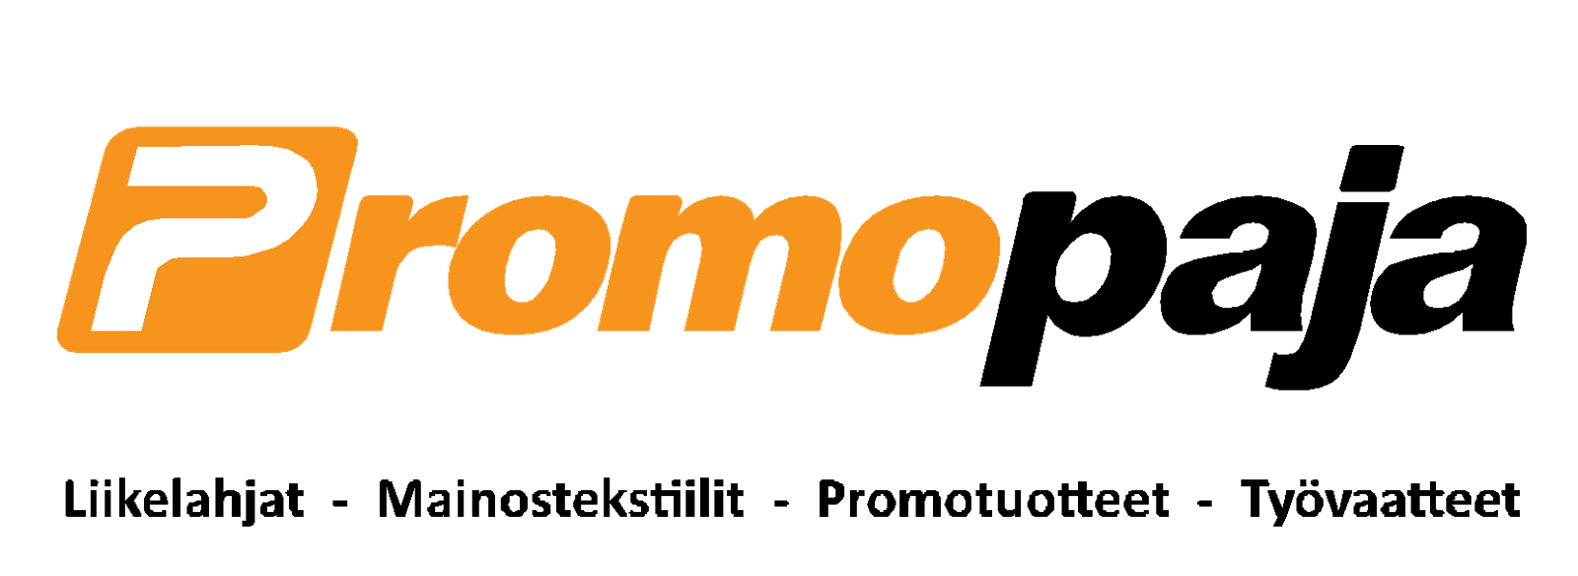

DISTRIBUTION LIST

FIN: EsJt, ETK, EVT, HaTal, HeiTa, HL, HSK, HTK, HTL, HyTL, JTL, JoKa, JyTLS, Kajaanin Elo, KaTa, Kemin Lämärit, KeLS, KeuPa HT, KJ, KK, KooVee, KoTa, KouJt, KSK, KTL, KuLS, KuTa, LL, LTL, LrTL, MJT, ML, MTK, NTL, OLK, OTK, PoriTa, PTL, RauTL, RNK, RTL, SaTu, SeiTL, STR, SäNv, TapTL, TL, TRT, TTK, Uplakers Taitoluistelu, VaPS, Varala, VarTa, VG-62, VLK, STLL, judges

RUS: Figure Skating Federation of Russia, Dinasty St. Petersburg, Sdush Voronezh

SWE: Svenska Konståkninsförbundet, Upplands Väsby Konståkning, Malmö Konståkningsklubb, IFK Västerås Konståkningsklubb

NOR: Norges Skøyteforbund

EE: Eesti Uisuliit, Rocca al Mare Uisukool, Tiiu Valgemäe Uisukool

AT: Skate Austria

IT: Ice Club Torino

LT: Lithuanian Skating Federation

LV: Latvian Skating Association, Kristal Ice

BY: Skating Union of Belarus

CZ: Czech Figure Skating Association

DK: Dansk Skøjte Union

